**Team 3 Week 9 Deliverables**

**This Weeks Project Velocity**

10 Use Cases Finished – Medium Productivity Week

The Medium productivity was likely due to personal commitments; several team members were busy with events in their personal lives that prevented them form working as much. Also the fourth of July holiday was this week and the team did not work on this day.

**Status for Sprint 2**

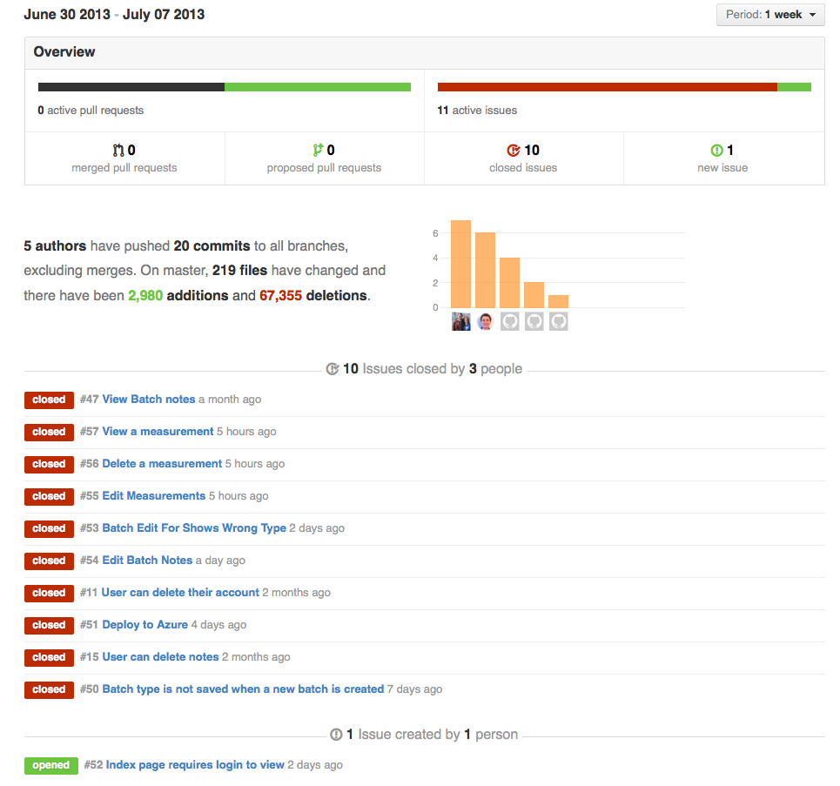

Each of the use cases that were completed this week is shown above. In addition, one new issue was filed this week and has been added to the backlog. All items that were not completed in Sprint 2 have been moved back onto the backlog. They will be reprioritized at the start of Sprint 3. There are currently 23 issues on in the backlog. Some of them have some progress made, but were not completed in time for the Sprint 2 deadline. Most have not yet been started.

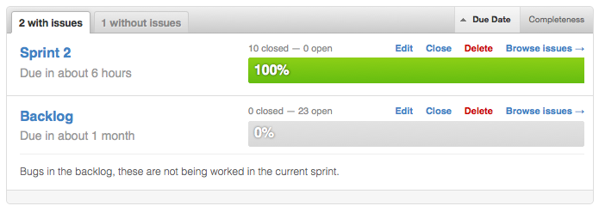

**Test Results**

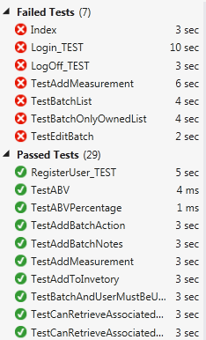

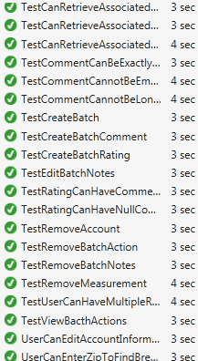

**Sprint 2 Review: Key Functionality**

* 1. **Deployment to Azure**



The deployed system can be seen and used at the URL: <http://homebrew.azurewebsites.net/> this is the production version of the site and is updated with each commit. Anyone can create an account on the site and use the application in its current state.

* 1. **Log-In Return When Trying to Directly Click on Recipes**

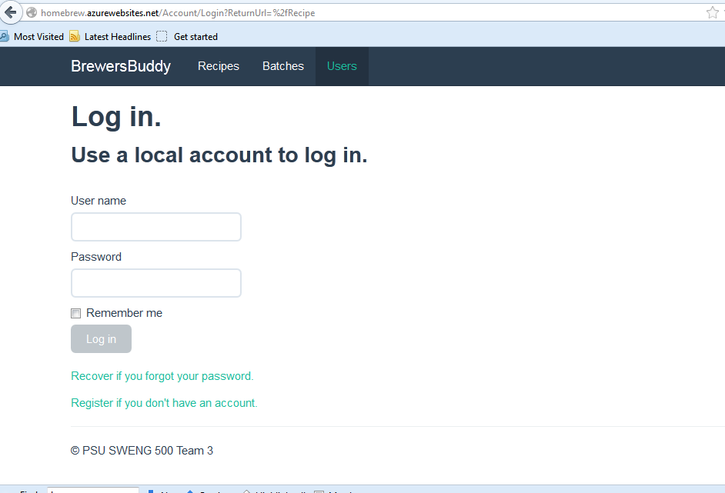

* 1. **UI Refinement**

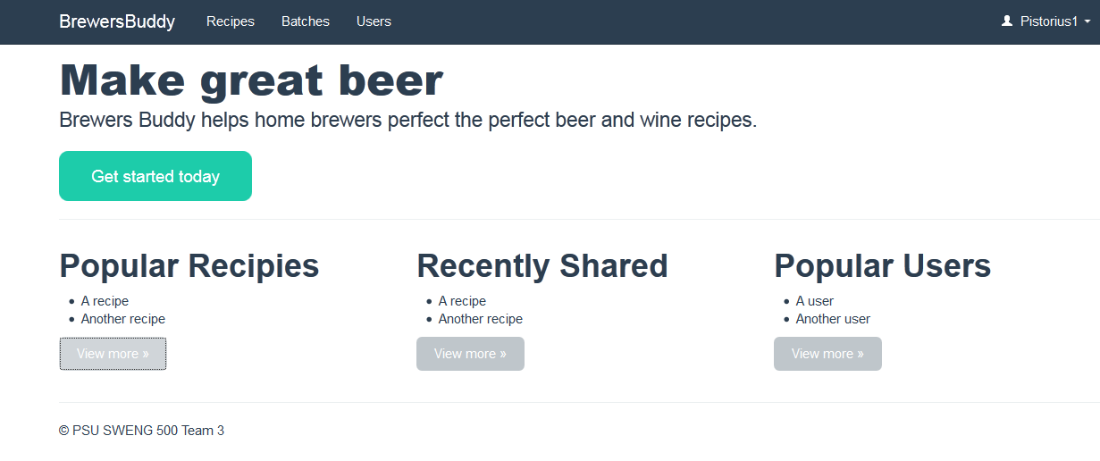

* 1. **Additional UI Refinement**

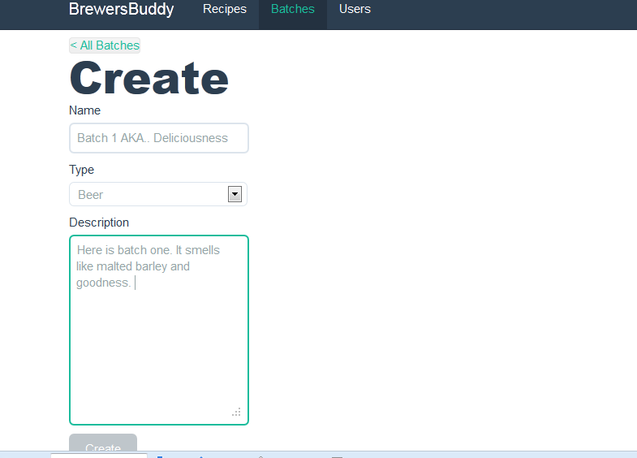

* 1. **Added Measurements and Readings to a Batch**

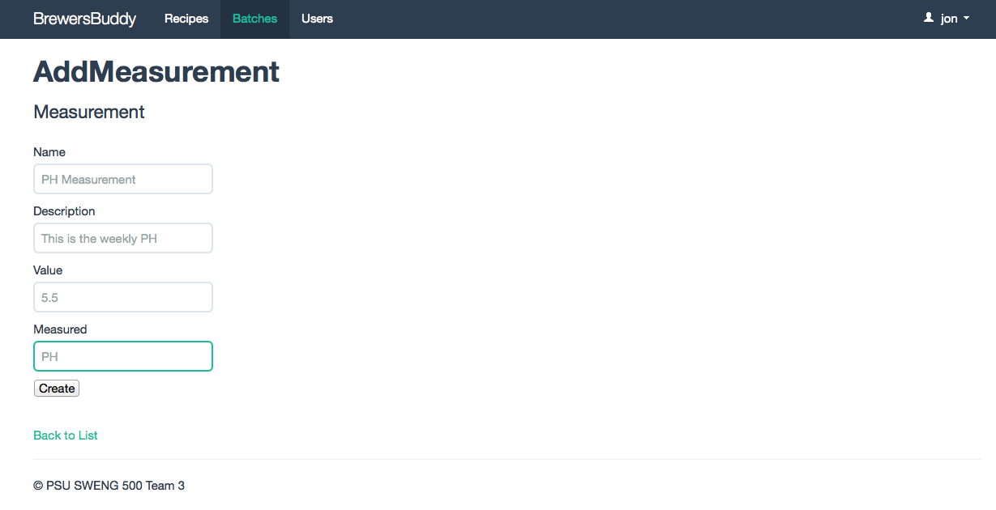

* 1. **User Can Add Notes About a Batch**

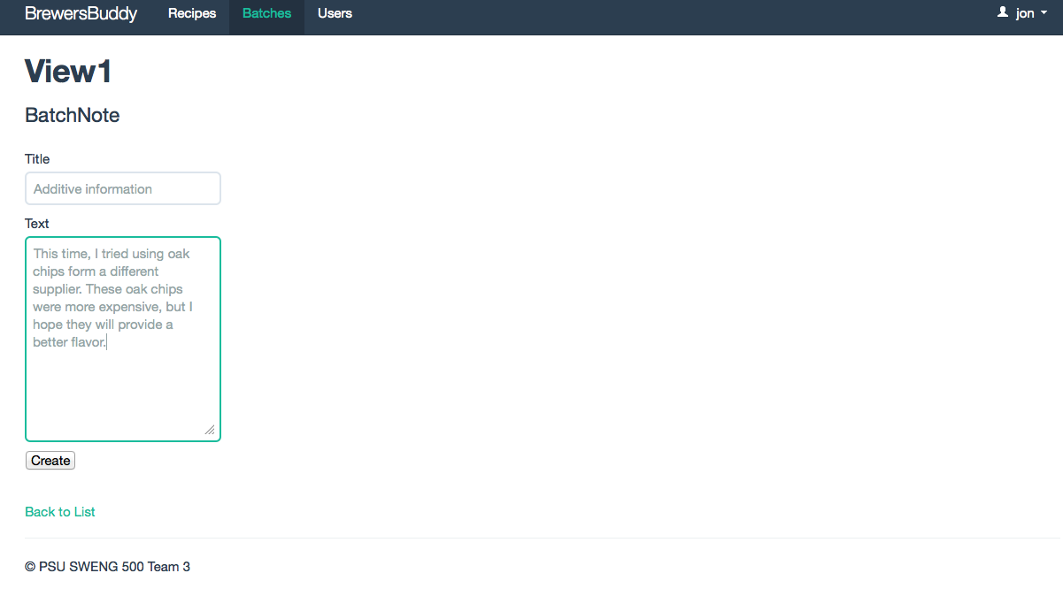

* 1. **User Can Delete a Batch**

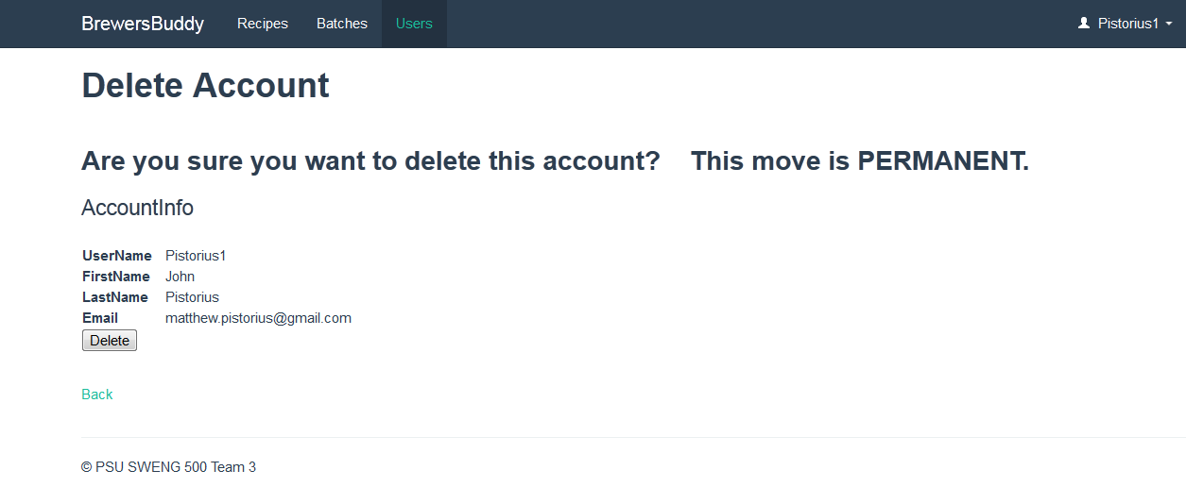

## Selected Code Samples

### Delete User Account

### 

### Unit Test For Deleting Account

### 

### UI CSS Changes

### 

### Add Measurements To Batch

### 

**2. Retrospective**

### What Went Well

1. The user interface is becoming coherent and usability is improving. Compared to last sprint, our interface is much more usable and looks much better.
2. Deployment to Azure.  PAL can now see and use our application and give feedback.
3. The new user interface looks much better.
4. We are all learning. Greg specifically has learned a lot and become able to contribute more.
5. We're getting to the point where portions of the product are usable.
6. We're getting better at the ASP MVC framework.

### What could be improved

1. Communication can be better We often don’t know what others are working on.
2. Our test coverage seems to be slipping. This is mainly because we are having trouble determining how to implement tests for some scenarios. In some cases, the framework does not make testing easy at all.
3. Our migration files and database seems to have gotten out conflicted and broken in some way.
4. Gregg is having problems with GitHub.  He is unable to select or deselect assignee, labels, and milestones. We don’t know why this is only happening to him.
5. Team members were busy in their personal lives and the sprint velocity decreased.
6. We still have some key use cases we need to work on.
7. We should try to meet more often.
8. Coordination, we really haven't been planning out our goals or direction. It seems like everyone is just picking some random thing to work on. Our efforts are not coordinated.
9. Backlog management, as we move into the final sprint, we will need to make difficult decisions about what is worked on and what is not. Some features will likely slip and not be completed. It is unclear how we are going to make these determinations and prioritize our work.

## 2.4 Additional Accomplishments

* Cleaned up the Add Batch note functionality.
* Added the NSubstitue framework to our project for using Mock objects in unit tests.
* Fixed RemoveBatchNoteTest.
* Mocked frameworks and converted all tests to NUnit from MSTest
* Fix to allow batches with notes to be deleted
* Updated Use Cases & Software Requirements Specification
* Further progress with adding batch actions, but still blocked by a bug.
* Fixed bug in search to not show "No Results when results are shown"
* Added search functionality to Users link (before I knew that it was on backlog)
* Fixed BrewsBuddy link to take user to home page.
* Users can now delete their account
* Added TestRemoveAccount (passes)
* Users can look up friends